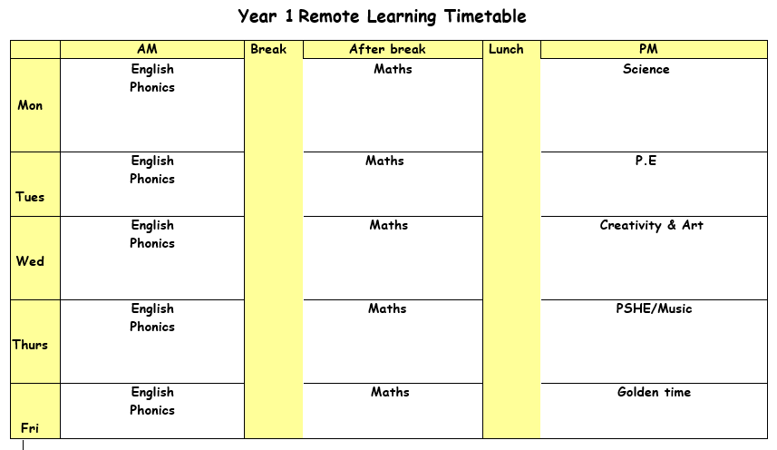
Bug club
All of the children have now moved up a stage in their bug club books. Please make sure you are answering the questions that are linked to your child’s books. We are monitoring bug club and will be changing books on a Monday for those children that have read their books.
Feedback and rewards
Please could you send in work on the day, if this is not possible then please ensure work is sent on the correct week. We are trying our best to reply and give feedback on the day the work is sent in. We have also introduced J2Stars, these are similar to stickers and we are giving these out to children who have completed their work. There is a special bonus sticker for those children that complete ALL of the days work.
Learning packs
Don’t forgot to collect packs on FRIDAY between 12:30 – 2:30.

Monday 8th February 2021

ENGLISH: Reading time (revision from last week)
Click on the link and listen to the two poems If You Should Meet a Crocodile and The Vulture.
- What things do the poems have in common?
- Which do you like the best? Why is that?
- Activity: Choose either the crocodile or vulture picture. Label the different parts of your animal with words and short phrases (e.g. beak, feathers, big bald head, very sharp claws for holding things etc.)
Challenge: We have been learning about lots of different animal groups in Science. You can choose an animal of your choice and label the different parts.
PHONICS: Follow the link for your phonics lesson today on the ‘c’ sound. https://youtu.be/1JwMUIB0EKI Remember to write down all of your learning in your remote learning books and send a picture to your class teacher on J2E.
BREAK
MATHS: Today we are going to be looking at 2d shapes and their properties. You need to open and go through the ‘2D shapes’ PowerPoint. You can use the word mat and the PowerPoint to help you complete the worksheets.
Blue group- You need to cut out the shapes to match the properties of the shapes so that the shape and the properties are matching one another.
Red group- You need to fill in the 2d shape properties table.
Green group- You need to name the shapes and count the number of sides.
LUNCH
READING: Read one of your bug club books for this week. Predict what you think might happen half way through your book. Write your prediction in your remote learning book. Carry on reading the book and see if your prediction was correct.
SCIENCE: Activity one – Go through PowerPoint ‘What do I eat?’ and click on the sound icon to read the PowerPoint to you.
- Activity two – Look at the pictures on the Science worksheet. Decide if each animal is a carnivore, a herbivore, or an omnivore. Sort each card into the right group.
ASSEMBLY: Find the PowerPoint for today’s assembly on ‘E-safety’. We have been doing lots of work on e-safety in our computing lessons so you should have all the answers to the questions.
Tuesday 9th February 2021

ENGLISH: Reading time and sequence events in the poem. Click on the voice clip to hear the teacher read the poem Dad and the Cat and the Tree by Kit Wright.
Activity two: Cut up and shuffle the set of Dad Cat and Tree Picture Cards. Read the captions and look at the pictures, place the cards in the correct order on the two empty grids (one grid for green group). When you are sure you have got them in the right order, glue the pictures down. Number them 1 – 12 (1-6 for green group). Later, colour your cards in and use them to tell someone else the story.
Challenge: Can you retell the poem to someone else?
PHONICS: Follow the link for your phonics lesson today on the ‘g’ sound. https://youtu.be/WuWqrTDBxBs Remember to write down all of your learning in your remote learning books and send a picture to your class teacher on J2E.
BREAK
MATHS: Today we are looking at 3d shapes and their properties. You need to open the PowerPoint ‘3D shapes PowerPoint’ and go through the slides. You can use the word mat and the PowerPoint to help you complete the worksheets.
Blue group- You need to count the edges/faces and vertices.
Red group- You need to complete the 3D shape properties table.
Green group- Match the 3D shapes to their names.
LUNCH
STORYTIME: Listen to Ms Adam read a story.
PE: Find the PE PowerPoint and work your way through following the instructions given. You can then complete 3 animal just dances of your choice. At the end of the PowerPoint there is the health work you need to read and answer. Remember to write down all of your answers into your remote learning book.
Extension – Mr Ruparelia has recorded some PE videos for you on YouTube to have a go at. There are some tasks that you may need a partner for and some you can complete yourself.
Reaction game – https://youtu.be/syptzSHjdOc
Fitness challenge - https://youtu.be/541az6OAARA
READING: Pick a book that you enjoy reading. Write about a memory or experience of your own that is similar to something you have read in your book. For example if your book is about a trip to the seaside, think about a time where you have been to the seaside or on holiday. What did you do there? Who did you go with?

Wednesday 10th February 2021
ENGLISH: Writing time
Click on the YouTube https://www.youtube.com/watch?v=8JJgENPnYb4 to see the poem from yesterday.
What might happen next? How will Dad get out of the tree? Will someone have to go up to rescue him?
- On What Happens Next draw what you think will happen now that the Dad is stuck in the tree.
- Write some sentences under your picture. Remember to use capital letters to start your sentences and full stops to finish them.
Challenge: To use a conjunction in your sentence or punctuations.
PHONICS: Follow the link for your phonics lesson today on the ‘ie’ sound. https://youtu.be/0eWsqCLdFzU Remember to write down all of your learning in your remote learning books and send a picture to your class teacher on J2E.
HANDWRITING PRACTICE: Practise the next letter in your handwriting booklet. Try and think of words with these letter in and then write a list of words in cursive handwriting into your remote learning books.
BREAK
MATHS: Today we are going to be comparing 2D and 3D shapes.
Blue group- Use the word bank to match the correct 2D/3D name for each shape.
Red group- Write the correct 2D/3D name to match the shapes and read the challenge at the end.
Green group- Cut out the 3D and 2D shape names and match the names to the shapes.
LUNCH
READING – Pick one of your favourite story books to read. Make a list of questions that you would ask yourself as you read. For example ‘Why has the character done this?’

CREATIVITY: On Friday it is a special day. It is Chinese New Year! Like we have a new year on the 1st January, China celebrate their new year around February time. Find the PowerPoint ‘Chinese New Year’. Read through the PowerPoint and compare the similarities and differences of how you would celebrate New Year’s Day. For example, a special dinner you have, new clothes you wear or to have a party.
Activities: Dragon mask, Paper lantern and Chinese paper chain dragon

Thursday 11th February 2021
ENGLISH: Now try these Fun-Time activities.
- Write a short explanation on things at home that have made you laugh on Funny things that have happened in my family. Draw a picture of one of these.
Challenge: Explain to someone to say how you would get a cat out of a tree. Can you draw a picture of you saving the cat?
PHONICS: Follow the link for your phonics lesson today on the ‘ea’ sound. https://youtu.be/-aQa_JILgNA Remember to write down all of your learning in your remote learning books and send a picture to your class teacher on J2E.
BREAK
MATHS: Today we’re going to guessing the names of the shapes using properties of the shapes. You need to open the ‘Guess the shape’ PowerPoint and go through the
slides. The shapes are mixed up, they can be 2D or 3D shapes. Use the 2D and 3D shape mats from Monday and Tuesday to help you.
Blue group- Read the riddle cars to figure out the shape and write down what shape you think it is.
Red group- Read the riddle cars to figure out the shape and write down what shape you think it is.
Green group- Read the sentences to work out what shape it is describing.
LUNCH
READING: Log onto bug club and read one of your bug club books. Which character in your book would you most like to be? Explain your answer in full sentences and write them down in your remote learning books.
MUSIC: As it is Chinese New Year tomorrow we are going to have a look at some Chinese music. Today we are going to focus on the tempo and dynamics. Find the Chinese music PowerPoint and follow the instructions. There is a YouTube video that you will need to click on to hear the example of the music.
Activity 1: Make a Chinese drum.
Activity 2: Perform a piece of Chinese music with your Chinese drum.

Friday 12th February 2021
ASSEMBLY: Now that you have had a look at E-safety, you are going to be looking at E-safety at home for today’s assembly.
ENGLISH: In Science we have been learning about different types of animals. We are going to read or listen to a reading comprehension about hedgehogs.
Activity 2: Complete the worksheet with the correct answers. You may need to read the text again to find the answers.
PHONICS: Follow the link for your phonics lesson today on the ‘y’ sound. https://youtu.be/qYesh2TRbys Remember to write down all of your learning in your remote learning books and send a picture to your class teacher on J2E.
BREAK
MATHS: Today we are looking at everyday 3D shapes. You need to open the ‘everyday 3D shapes’ PowerPoint and go through the slides.
Blue group- Use the 3D/2D shapes on your sheet to search around your house to find them shapes. Draw what you find or take a picture matching the shape and the everyday object that you have found.
Red group- Use the 3D/2D shapes on your sheet to search around your house to find them shapes. Draw what you find or take a picture matching the shape and the everyday object that you have found.
Green group- Use the worksheet to tally and count how many 3D shapes you can find around the house.
LUNCH
STORYTIME: Listen to Miss Patel read a story.
Golden time

Have a fantastic and well-earned half term break!

