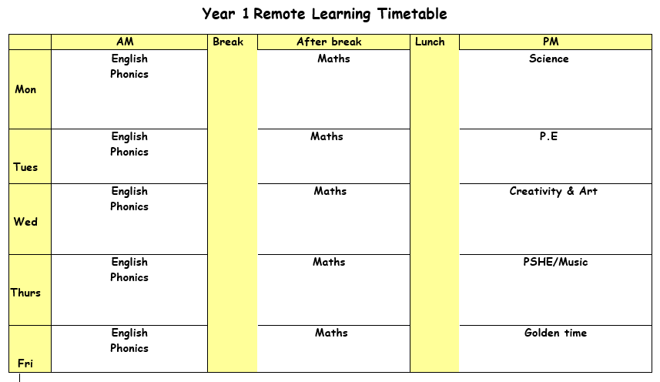

Bug Club
We are monitoring bug club and will be changing books on a Monday for those children that have read their books.

Feedback and rewards
Please could you send in work on the day, if this is not possible then please ensure work is sent on the correct week. Check your J2Stars to see how many you have earnt for the day. Remember there is a special bonus star for those children that complete ALL of the days’ work.

Learning packs
Don’t forgot to if you would like to, you can collect a learning pack on FRIDAY between 12:30 – 2:30.
Monday 22nd February 2021

ENGLISH: Today we are going to be doing a shared reading lesson with Mrs Sheikh. Go on J2E to find the link and the gingerbread man story pages. You can read along with Mrs Sheikh.
Highlight any adjectives you can find on your story pages.
PHONICS: Follow the link for your phonics lesson today on the ‘y’ sound. https://youtu.be/H7TwuyzXdWg Remember to write down all of your learning in your remote learning books and send a picture to your class teacher on J2E.
BREAK
MATHS: Today in maths we are looking at ordering numbers. You need to find the ‘ordering numbers PowerPoint’ and look through the slides.
Red group- You have mixed numbers to 100 which you are ordering using a 100 square to help you from the smallest number first.
Blue group- You have mixed numbers to 50 which you are ordering using a 100 square to help you from the smallest number first.
Green group- You have mixed numbers to 20 which you are ordering using a 100 square to help you from the smallest number first.
LUNCH
READING: Read one of your bug club books for this week. Finish this sentence “I love the way the author…” Give example of why you like what the author has written. Remember an author is somebody who writes a book.
SCIENCE: Today we are starting our new science topic all about materials. Open the ‘naming materials’ PDF. Work through the PowerPoint and answer the questions in your remote learning books.
Activity one – Find the ‘labelling materials activity sheet’.
Green group: You are going to use the material cards and match them to something in your house that is made of that material. Blue group: You are going to match the materials to the correct picture. Red group: You need to look at the pictures and write down what material each object is made out of. There are words on your sheet to help you.
Challenge – Can you find anything in your house that is made of mixed materials? For example, a chair is made out of plastic and metal.
ASSEMBLY: Find the ‘poverty’ assembly PowerPoint. Think about what you have and what you are grateful for.
Tuesday 23rd February 2021

ENGLISH: Find the PowerPoint ‘writing instructions’, follow the PowerPoint listening or reading the text. Then open the ‘features checklist’ and ‘fruit pizzas’, you are going to use the checklist to find the features on the fruit pizza recipe. You can highlight, underline or label the features, make sure they are nice and clear. If you can think of more features that are missing or that you have found add them on!
PHONICS: Follow the link for your phonics lesson today on the ‘ch’ sound. https://youtu.be/Y6iFiVLWjOo Remember to write down all of your learning in your remote learning books and send a picture to your class teacher on J2E.
BREAK
MATHS: Today you are looking at odd and even numbers. You need to open the Power Point ‘odd and even’ and go through the slides.
Red group- You need to count the food objects and write the number and decide if it is a odd or even number by circling which one you think it is.
Blue group- You need to count the ladybird spots and colour the ladybird red if it is an odd number of spots or yellow if there is an even number of spots.
Green group- Fill in the odd and even numbers. Once you have done that colour in the odd numbers in one colour and even numbers in another colour.
LUNCH
READING: Pick a book that you enjoy reading. How did the book make you feel? Write down 3 sentences in your remote learning book about how the book made you feel.
PE: Today we are starting a new topic all about ball skills. For this lesson you will need a ball or a sphere shaped object. Find the PE PowerPoint and work through following the instructions given. You then need to make the ‘exercise dice’, you will find this in your packs or on J2E. The health work is at the end of the PowerPoint, write down your answers into your remote learning books.

Wednesday 24th February 2021

ENGLISH: You are going to be writing your own recipe for a gingerbread man. Watch the YouTube video to see how to make gingerbread men https://www.youtube.com/watch?v=t4cGrvyO_no. Find the recipe template and start writing your recipes, add as much detail as you can because you will need this for tomorrows lesson! There are word mats on J2E for you to use if you need them, remember the features to include from yesterday’s lesson.
Green group: Find the recipe ordering cards, cut them out and put them in the correct order. You can use this to help with your writing.
PHONICS: Follow the link for your phonics lesson today on the ‘ch’ sound. https://youtu.be/t3CK7-yc-RU Remember to write down all of your learning in your remote learning books and send a picture to your class teacher on J2E.
HANDWRITING PRACTICE: Practise writing the first letter in your new handwriting booklet. Try and think of words with these letter in and then write a list of words in cursive handwriting into your remote learning books.
BREAK
MATHS: Today we are looking at repeated patterns. You need to open the patterns PowerPoint and go through the slides.
Red group- Complete the 3D shapes pattern and draw in the shapes to complete the pattern.
Blue group- Continue the shapes pattern by drawing in the shapes to complete the pattern.
Green group- Continue the shapes pattern by drawing in the shapes to complete the pattern.
LUNCH
READING – Pick a story book to read. Write a book review for what you have or have not enjoyed about the book.

CREATIVITY: We are going to start our new geography topic about the UK. Find the ‘UK- England’ PDF, go through the slides and answer questions in your remote learning books.

Activity 1: England fact cards, read through the facts and see if you can add any more.

Activity 2: Decorate the England flag. Be as creative as you like!

STORYTIME: Listen to Ms Adam read a story.

Thursday 25th February 2021
ENGLISH: Use the recipes you wrote yesterday to make your gingerbread men. If you did not finish or if you aren’t sure about your recipe, use the YouTube video from yesterday. Decorate your ginger bread men and think some of some adjectives to describe the way they look, taste and smell.
PHONICS: Follow the link for your phonics lesson today on the ‘ou’ sound. https://youtu.be/G0w6HzuCFvM Remember to write down all of your learning in your remote learning books and send a picture to your class teacher on J2E.
BREAK
MATHS: Today we are continuing with patterns. Recap the PowerPoint from yesterday.
Red group- Read and answer the pattern questions carefully. Record your learning in your remote learning books.
Blue group- Continue the pattern by drawing and colouring the shape pattern.
Green group- Continue the pattern by drawing and colouring the shape pattern.
LUNCH
READING: Find the gingerbread man story which matches your coloured group. Read through the story, remember to use your reading strategies. You then need to answer the questions on the last page. You can always go back and read the story if you are struggling to answer some of the questions.
PSHE: Today we are going to be looking at mental health and wellbeing. Think about the work we completed last term, these will help you answer the questions in today’s lesson. Find the ‘Positive mental health’ PowerPoint and listen or read through with the instructions in the lesson.
Activity: You are going to make a positivity jar with all the things that you are amazing at. There is a jar template and sentences that you can use or if you want to use your own you can. You can draw your positivity pictures as well, be as creative as you like! You might want to put on some calming music while you do this.

Friday 26th February 2021
ASSEMBLY: Find the PowerPoint ‘tackling poverty with Marcus Rashford’. Think about how Marcus has made a change for lots of people.
ENGLISH: Listen to the rest of the gingerbread story, follow the link on J2E to Miss Patel reading the story.
Red and Blue group: Find the gingerbread man changing the ending sheet. You are going to think of a new ending to the story, be as creative as you like!
Green group: Find the gingerbread new character sheet, you are going to make up a new character for the story of the gingerbread man. Write 3 sentences about your new character, remember to use adjectives and be as creative as you can.
PHONICS: Follow the link for your phonics lesson today on the ‘ey’ sound. https://youtu.be/sPedaTqYOCM Remember to write down all of your learning in your remote learning books and send a picture to your class teacher on J2E.
BREAK
MATHS: Today you have a matching activity. You are matching the numeral, number words and quantities together. You need to cut out the activity cards and mix them up and then match them to the correct amounts. Once you’ve completed the activity send it to us on J2E or record it in your remote learning books.
Red group- You are matching the numbers to 50
Blue group- You are matching the numbers to 30
Green group- You are matching the numbers to 20
LUNCH
READING: Log onto bug club and read one of your bug club books. Design a front cover for the book you have read. Use the ideas from the actual cover and what you know from what you have read.
Golden time

