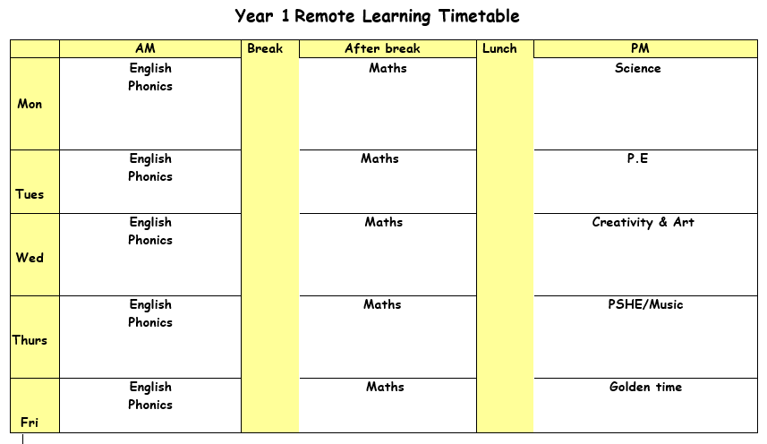

Monday 8th March 2021

ENGLISH: We are continuing the Fiction topic and reading the story of knuffle bunny today. ( see shared read plan). Click on link to listen to the story https://www.youtube.com/watch?v=6djo-p0OfRs .
Talk about their favourite toy and ask them to discuss with their partner. Use stem sentences and encourage speaking in full sentences. My favourite toy is…..
Activity – Identify characters from the Knuffle bunny story and write a sentence for each of them. Use C .

SPELLINGS – Phase 5 ph sound.
PHONICS: Follow the link for your phonics lesson today on the ‘ch (ture)’ sound.
Remember to write down all of your learning in your remote learning books and send a picture to your class teacher on J2E.
BREAK
MATHS: This week we are revising counting in 2,s5,s and 10s. Go through the PowerPoint and complete the worksheet. Use the number line to help you when you are counting.
LUNCH
READING: Find the reading racetrack on J2E or in your packs. Remember, when you read for 15 minutes or more to get one of your racetracks signed. Let’s see which class is going to be the winning class! You need to send a picture of your completed racetrack back to your teacher!
Read one of your bug club books for this week. Write a summary of your book to sum up the main events.
SCIENCE: Today we are going to be looking at the properties of materials. Some materials are hard and some are soft. Some materials are bendy and some are not. Look at the other words used to describe the properties of materials and check your understanding of what each word means. Go through the powerpoint.

Activity one – Look at the different objects in the tray and tick or use the correct vocabulary to describe each one.
Challenge – Toy building blocks used to be made from wood. Why do you think they are now made from plastic?

Tuesday 9th March 2021

ENGLISH: Revise the story read yesterday and look back at the speech bubbles. Can you read them? What do you think Trixie was saying and why she could she not say it clearly? What punctuation clues are there? ! ?
Activity – Choose one of the pages where Trixie is speaking. Build a sentence verbally to translate Trixie’s words. Then record this into a speech bubble.
Green group - use ‘and to link two ideas together e.g Knuffle bunny went to the park and bought an ice cream.
Blue group – Use adjectives in your sentences.
Red – Use ! or ? in your sentences.

PHONICS: Follow the link for your phonics lesson today on the ‘ch (tch)’ sound.
Remember to write down all of your learning in your remote learning books and send a picture to your class teacher on J2E.
BREAK
MATHS: Today we are going to revise doubling. Look at the numbers on the worksheet and double the numbers.
MENTAL MATHS: Next week’s test will be based on multiplication or groups of.Green group will counting in groups of 2s up to10 e.g 2 lots of 10…... Blue group will be counting in groups of 2s and 10s and Red group will count I groups of 2s, 5,s and 10s. The test will take place on 15.03.21.
LUNCH
READING: Pick a book that you enjoy reading. Write a letter the author of your book. Tell them what you think of their book and any questions that you would want them to answer. You could even ask them what it is like to be an author.
PE: Click on the youtube lick to complete your P.E lesson.
https://www.youtube.com/watch?v=OozWcmne_eM .

Wednesday 10th March 2021

ENGLISH: Read the rest of the story and ask chn to remember what has happened so far in the story. Recap the characters before the story starts. Explain that the story is set in New York, USA, so some words might be different e.g laundromat. Draw a simple story map on the board.
Today we are going to plan our writing. Our writing task for this week is to write a lost toy story. ask chn to use the planning sheet to help them think of a time when they might have lost their toy.
PHONICS: Follow the link for your phonics lesson today on the ‘j (dge)’ sound.
Remember to write down all of your learning in your remote learning books and send a picture to your class teacher on J2E.
HANDWRITING PRACTICE: Practise writing the next letter (f) in your new handwriting booklet. Try and think of words with these letter in and then write a list of words in cursive handwriting into your remote learning books.
BREAK
MATHS: Today we are going to revise halving. Look at the numbers on the worksheet and Halve the numbers.
LUNCH
READING – Pick a story book to read. Draw a picture of your favourite part of the book. Write what is happening in the picture and say why you chose this bit of the book.

CREATIVITY: We are going to carry on with our geography topic about the UK. Find the ‘UK - Wales’ PDF, go through the slides and answer questions in your remote learning books.

Activity 1: Decorate the Welsh flag. Be as creative as you like!

Thursday 11th March 2021
ENGLISH: (Shared write) Today we are going to write the story of the lost toy. Think of an exciting title for your story. Look at the example.
PHONICS: Follow the link for your phonics lesson today on the ‘m (mb)’ sound.
Remember to write down all of your learning in your remote learning books and send a picture to your class teacher on J2E.
BREAK
MATHS: Today we will be looking at sharing items into groups of two. Draw a circle around two rabbits to help you group them into groups of two. How many groups can you fit them into?
LUNCH
READING: Log onto bug club and read one of your bug club books. Write down three questions you would ask someone to check they have read the book carefully.

Friday 12th March 2021
ENGLISH: In English today we are going to be looking at using conjunctions. The conjunctions we are looking at today are ‘and’ and ‘but. Find the PowerPoint and follow along, remember to write down your answers into your remote learning books. For your activity you need to find the sheet that matches your coloured group and add in the correct conjunction. It would be nice to see you having a go at re-writing the sentences!
PHONICS: Follow the link for your phonics lesson today on the ‘z (se)’ sound.

Remember to write down all of your learning in your remote learning books and send a picture to your class teacher on J2E.
BREAK
MATHS: Use the number line to help you to group the items correctly. Remember to use your knowledge of counting in 2s,5s and 10s.
LUNCH
Golden time

