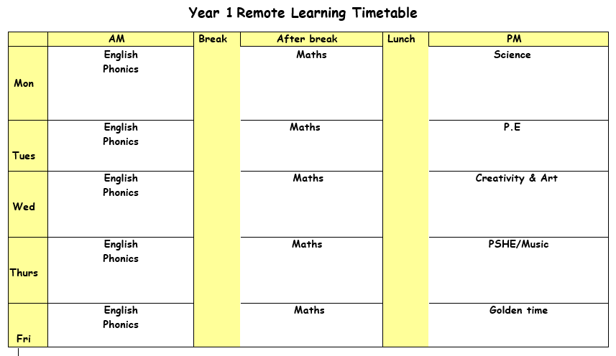

Monday 15th March 2021

ENGLISH: We are starting a new topic which is poetry this week. Do you remember any poems we have read? Go through the PowerPoint on rhyming words and complete the activity.
Activity – Green group and blue group – cut out the words and match them with the correct rhyming word.
Red group – Read each word on the worksheet and think of another rhyming word e.g cats – bats.

SPELLINGS – Practise spelling the words with the long ‘igh’ sound.
PHONICS: Click on the powerpoint on the school website for the ie (tie) sound.
Remember to write down all of your learning in your remote learning books and send a picture to your class teacher on J2E.
BREAK
MATHS:
LUNCH
READING: Find the reading racetrack on J2E or in your packs. Remember, when you read for 15 minutes or more to get one of your racetracks signed. Let’s see which class is going to be the winning class! You need to send a picture of your completed racetrack back to your teacher!
Read one of your bug club books for this week. Write a summary of your book to sum up the main events.
SCIENCE: We are celebrating British Science Week, the theme for this year is and we are going to be looking at which material would be the best at keeping Winne the Pooh dry. Look at the powerpoint and go through how you need to carry out the experiment. You will need to collect all the materials from the worksheet before you start.

Activity: follow the instructions from the powerpoint and complete the investigation.
When you have finished show your results on the worksheet.

Tuesday 16th March 2021

ENGLISH: Recap verb (doing or actions words) Go through the PowerPoint on word endings. These are called suffixes. Then complete the worksheets.
Red – Cut out sentences and put into the correct column (past and present).
Blue – Choose the correct ending and add to the word in the table.
Green – Cut out and read each word. Choose the correct ending and add to the word.

PHONICS: Click on the powerpoint on the school website for the i-e sound (like).
Remember to write down all of your learning in your remote learning books and send a picture to your class teacher on J2E.
BREAK
MATHS: To identify objects longer or shorter than a meter. Look around the classroom and estimate objects that are longer or shorter than a metre. Write down names of objects once you have measured.

MENTAL MATHS: Last week we looked at how to double numbers. Use the same method to practise doubling numbers for your test next week.
LUNCH
READING: Pick a book that you enjoy reading. Write down one thing you enjoyed about the book.
PE: Complete P.E with Joe Wicks.

Wednesday 17th March 2021

ENGLISH: Read the playtime poem and underline the verbs e.g pull. Add ing/ed to the words in the column.
PHONICS: Click on the powerpoint on the school website for the o-e (home) sound.
Remember to write down all of your learning in your remote learning books and send a picture to your class teacher on J2E.
HANDWRITING PRACTICE: Practise writing the next letter (d) in your new handwriting booklet. Try and think of words with these letter in and then write a list of words in cursive handwriting into your remote learning books.
BREAK
MATHS: To compare weight of objects. Look at the balance scales on the worksheet and colour the heavier and lighter items in different colours.
LUNCH
READING – Pick a story book to read. Draw a picture of your favourite part of the book. Write what is happening in the picture and say why you chose this bit of the book.

CREATIVITY:

Thursday 18th March 2021
ENGLISH: Think of some verbs that describe what it is like at home time e.g noisy, shout and write your own home time poem similar to the playtime poem you read yesterday. E.g parents calling,
Children shouting.
PHONICS: Click on the powerpoint on the school website for the a-e (make) sound.

Remember to write down all of your learning in your remote learning books and send a picture to your class teacher on J2E.
BREAK
MATHS: To find the difference between the cube towers. Look at the towers and count the different in cubes for each one. If you have cubes you might want to build the towers and then find the difference.
LUNCH
READING: Log onto bug club and read one of your bug club books. Write down three questions you would ask someone to check they have read the book carefully.

Friday 19th March 2021
ENGLISH: In English today we are going to be looking at a variety of poems written by different authors. Once you have read the poems you will use the review sheet to write an answer to the questions.
PHONICS: Complete the reading comprehension worksheet.

Remember to write down all of your learning in your remote learning books and send a picture to your class teacher on J2E.
BREAK
MATHS: Ask and adult to help you use the kitchen scales in your house to weigh different items. Try and guess the weight of the item before you weigh it and use the words heavier and lighter to compare objects with each other.
LUNCH
Golden time

