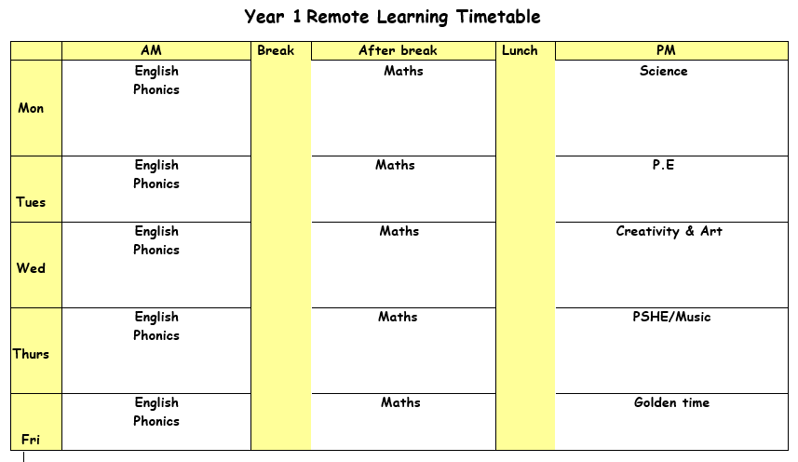

Monday 26th April 2021

ENGLISH:(shared Read). Display the front cover of Dear Greenpeace. Explain that Greenpeace are an organisation of people who help and encourage people to look after the planet.
Say the book is an exchange of letters between a girl called Emily and Greenpeace.
Read the story. Stop at page 12.

Activity: Work in pairs to read the first six letters from Dear Greenpeace.
Children take it in turn to read each letter aloud. Encourage the children to read each letter at least twice, to help consolidate their reading fluency and confidence.
They discuss the purpose of each letter and record their ideas as words/phrases. This could be written on the letters or in books.
Green: Children match the purpose to the correct letter (resources).

SPELLINGS & MENTAL MATHS–
Activity 1 – Complete your spellings and mental maths test from last week (more or less than).
Activity 2 - Mental Maths is to add and subtract 10 from a number correctly. Practise spellings using the different ur, er, ir sounds.
PHONICS: Use the PowerPoint on the school website for the phonics lesson today on the ‘a’, sound. Remember to write down all of your learning in your remote learning books and send a picture to your class teacher on J2E.
BREAK
MATHS: Today we are going to be looking at doubling number to 20. Look at the powerpoint called ‘doubles to 20’. If it helps to draw the amount into two groups to work out the doubles you can do that to help you.
LUNCH
READING: Find the reading racetrack on J2E or in your packs. Remember, when you read for 15 minutes or more to get one of your racetracks signed. Let’s see which class is going to be the winning class! You need to send a picture of your completed racetrack back to your teacher!
Read one of your bug club books for this week. Write a summary of your book to sum up the main events.
SCIENCE: This week we are going to be looking at Wild plants. Use the worksheet to help you identify as many plants as you can. Ask an adult to walk around your garden or local area to see how many times you can see each plant.

Activity one – Use the worksheet to tally the number of plants you can see.

Tuesday 27th April 2021

ENGLISH: Go through the PowerPoint looking at sentence punctuation. Then choose the worksheet you are most confident with and complete the activity.

PHONICS: Use the PowerPoint on the school website for the phonics lesson today on the ‘e’, sound. Remember to write down all of your learning in your remote learning books and send a picture to your class teacher on J2E.
BREAK
MATHS: Today we are going to be looking at halving number from 20. Look at the PowerPoint called ‘halving PowerPoint’. If it helps to draw the amount into two groups to work out half of the number, you can do that to help you.
LUNCH
READING: Pick a book that you enjoy reading. Think of a question you would write to the author of the book.
PE: PE with Joe Wicks. Just dance or cosmic kids’ yoga on YouTube. Write down as many bones that you know from your body.

Wednesday 28th April 2021

ENGLISH: Today you are going to be sentence building. Red group you are going to be writing the questions to the worksheet. Blue group you are going to be correcting your capital letters and full stops. Green group you are going to cut out the sentence and re-organise it to make it a correct sentence.
PHONICS: Use the PowerPoint on the school website for the phonics lesson today on the ‘i', sound. Remember to write down all of your learning in your remote learning books and send a picture to your class teacher on J2E.
HANDWRITING PRACTICE: Practise writing the next letter in your new handwriting booklet. Try and think of words with these letter in and then write a list of words in cursive handwriting into your remote learning books.
BREAK
MATHS: Today in maths we are going to be looking at sharing in 2’s, 5’s and 10’s. Follow the video link for sharing into 2’s,5’s and 10’s. https://kids.classroomsecrets.co.uk/resource/sharing-equally-2s-5s-and-10s-video-tutorial/ You need to read the questions carefully to see how many you have to begin with and how many groups you need to share the amount into. Circle the groups that you need to share them into. E.G if the questions asks you share 10 bananas into groups of 2 then you need to circle 2 bananas in each group.
LUNCH
READING – Pick a story book to read. Draw a picture of your favourite part of the book. Write what is happening in the picture and say why you chose this bit of the book.

CREATIVITY: For today’s geography lesson we are going to look at a map of the school grounds. First you need to find the ‘map symbols’ PowerPoint and add the symbols onto your map of the school. Use the map and the compass to find which direction you need to walk in and how far each point is.

Thursday 29th April 2021
ENGLISH: Read Dear Greenpeace and ensure are familiar with what the book is about. Sequence the story and discuss Emily’s emotions at different stages in the story. Notice the different features of each letter, e.g. tone, style, format, purpose, opening/closing, sentence punctuation etc.
Today they are going to write a letter to the WWF explaining that an unusual animal has come to live with them and requesting additional information about it.
Green: Read and complete each sentence (resources).
Blue and Red: Use lots of adjectives to add description and detail.
PHONICS: Use the PowerPoint on the school website for the phonics lesson today on the ‘o', sound. Remember to write down all of your learning in your remote learning books and send a picture to your class teacher on J2E.
BREAK
MATHS: Today in maths we are going to be continuing with work on sharing in 2’s, 5’s and 10’s. Follow the video link for sharing into 2’s,5’s and 10’s. https://kids.classroomsecrets.co.uk/resource/sharing-equally-2s-5s-and-10s-video-tutorial/ You need to read the questions carefully to see how many you have to begin with and how many groups you need to share the amount into. Circle the groups that you need to share them into. E.G if the questions asks you share 10 bananas into groups of 2 then you need to circle 2 bananas in each group.
LUNCH
READING: Log onto bug club and read one of your bug club books. Write down three questions you would ask someone to check they have read the book carefully.
MUSIC: Practise speaking in a low and high pitch. Have a go at singing your favourite nursery rhyme in different pitches. When you are listening to music, think about what pitch it is.

Friday 30th April 2021
ENGLISH: Today we are going to be matching captions to the pictures. Red and blue group you are going to write your own captions for the four pictures. Green group you need to read the captions and match them to the correct picture.
PHONICS: Use the PowerPoint on the school website for the phonics lesson today on the ‘u', sound. Remember to write down all of your learning in your remote learning books and send a picture to your class teacher on J2E.
BREAK
MATHS: Today you are going to recapping halving and doubling to 20. Read the questions carefully and decide if you need to half or double the number and remember if it helps then you can draw the amounts on a piece of paper or a whiteboard to help you double or half the number. You can look at the video’s from Monday and Tuesday to help recap how to double and half numbers.
LUNCH
Golden time

