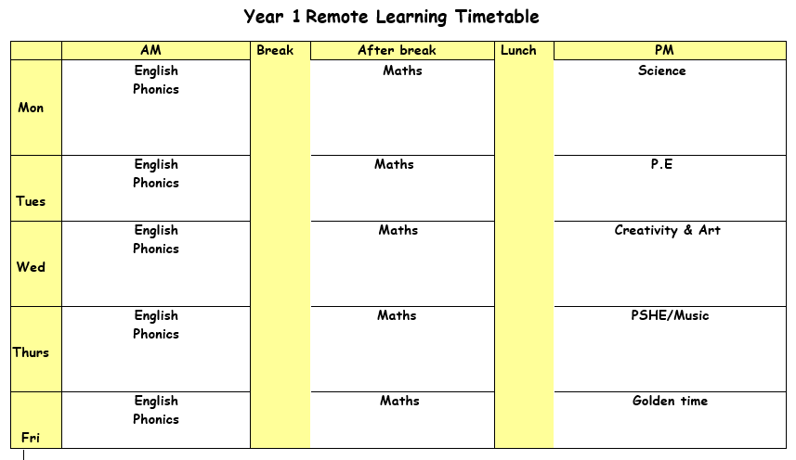

Monday 10th May 2021

ENGLISH: For English this week we are going to start looking at poems about nature. Do you know what nature is? Nature is all around us. Read the poem Nut Tree by Julia Donaldson. Do you know who she is? Do you know of any other things she has written?
Complete shared reading of Nut Tree making sure you understand all the words. Notice that the poem retells the lifecycle of a nut tree.
Give each group part of the poem Nut Tree and ask children to perform the poem the poem. Look at the resource performing poetry perfectly to help you.

SPELLINGS & MENTAL MATHS–
Activity 1 – Complete your spellings and mental maths test from last week (halving a number).
Activity 2 – Next week’s Mental Maths is to recognise time. Green group will be looking at time to the hour, blue group are looking at hourly times and half past, red group are looking at times before and after an hour and half past. Practise spellings using the different air and are sounds.
PHONICS: Use the PowerPoint on the school website for the phonics lesson today on the ‘y’, sound. Remember to write down all of your learning in your remote learning books and send a picture to your class teacher on J2E.
BREAK
MATHS: Today in maths we are going to be looking at weight. We are going to be looking at objects that are lighter and heavier. You need to go through the powerpoint called ‘Monday maths PowerPoint’.
Activity:
Blue group: You are organising the pictures of the objects into the heavy and light column.
Red group: You are looking at the objects at the bottom of the worksheet and organising them to go onto the correct parts of the weighing scale. Stick the pictures of the objects once you have made a final decision on where they should go.
Green group- You need to tick the object that is the heaviest.
LUNCH
READING: Find the reading racetrack on J2E or in your packs. Remember, when you read for 15 minutes or more to get one of your racetracks signed. Let’s see which class is going to be the winning class! You need to send a picture of your completed racetrack back to your teacher!
Read one of your bug club books for this week. Write a summary of your book to sum up the main events.
SCIENCE:

Activity one –

Challenge –

Tuesday 11th May 2021

ENGLISH: Today we are going to use the writing-frame (resources) and a copy of Nut Tree.
Read through the poem, discuss what is described in each stanza and identify each stage in the lifecycle of the nut tree. Then draw a picture to represent each stanza onto the writing-frame.

PHONICS: Use the PowerPoint on the school website for the phonics lesson today on the ‘ch’, sound. Remember to write down all of your learning in your remote learning books and send a picture to your class teacher on J2E.
BREAK
MATHS: Today you are going to be recapping weight today. We are going to be ordering and comparing objects from the lightest to the heaviest.
Activity:
Blue group- You are going to be comparing the objects from the lightest to the heaviest.
Red group- You are going to be comparing the objects from the lightest to the heaviest.
Green group- You are going to be ordering the objects from the heaviest to the lightest. You need to cut and stick the objects in order from the heaviest to the lightest.
LUNCH
READING: Pick a book that you enjoy reading. Think of a question you would write to the author of the book.
PE: PE with Joe Wicks. Just dance or cosmic kids yoga on YouTube. Follow the link to the Oak Academy PE lesson, you will be learning about how to stay safe whilst doing different exercise. https://classroom.thenational.academy/lessons/how-do-i-feel-safe-experience-success-and-feel-happy-60t3ad

Wednesday 12th May 2021

ENGLISH: For todays lesson The Secret Song (resources) you will need two different coloured pencil crayons.
Read through the poem together; encourage them to re-read it several times.
After, highlight each question sentence in one colour and each response in another.
Look at the animals on the worksheet. Can you prepare a question and an answer for each animal?
PHONICS: Use the PowerPoint on the school website for the phonics lesson today on the ‘ch', sound. Remember to write down all of your learning in your remote learning books and send a picture to your class teacher on J2E.
HANDWRITING PRACTICE: Practise writing the next letter in your new handwriting booklet. Try and think of words with these letter in and then write a list of words in cursive handwriting into your remote learning books.
BREAK
MATHS: Today we are going to be looking at capacity in maths today, You need to go through the powerpoint, ‘Wednesday maths powerpoint’. You have a capacity word mat to help you understand capacity better.
Activity:
Blue group: You need to label the bottles according their capacity. Look at the pictures carefully and match the labels to the bottles.
Green group: You are ordering the potion bottles according to capacity. Use the capacity word mat to help you.
Red group: You are measuring in capacity, read the sentences carefully and colour the objects in according to the amount in each one to match the label.
LUNCH
READING – Pick a story book to read. Draw a picture of your favourite part of the book. Write what is happening in the picture and say why you chose this bit of the book.

CREATIVITY: We are going to be planning our creation of an outdoor art piece inspired by Andy Goldsworthy. Find the PowerPoint all about Andy Goldsworthy, look at the pictures of Andy’s artwork. Find the ‘Andy Goldsworthy worksheet’, look at his pieces of work and fill in what you think about his work. You are going to plan your piece or artwork in the box at the bottom of the sheet.
Challenge: Complete as many of the ‘land art challenge cards’ as you can.

Thursday 13th May 2021
ENGLISH: Writing. Read In My Garden (resources). Did you notice that the poet has structured each stanza around one of their senses? Reread and identify each sense. Discuss the ideas the poet has included. Which senses has she not used? touch and taste.
Today you will be using your senses to generate ideas for a new nature poem.
Choose a sense, e.g. sight. Can you write exciting descriptive ideas for things you might see if they went out in nature, e.g. tiny, grey woodlice with slender, pale antennae; beautiful, emerald green butterflies.
Repeat with an alternative sense and complete the worksheet.
PHONICS: Use the PowerPoint on the school website for the phonics lesson today on the ‘ou', sound. Remember to write down all of your learning in your remote learning books and send a picture to your class teacher on J2E.
BREAK
MATHS: Today you are going to be recapping capacity. You can go through the powerpoint from yesterday to help you remember how we measure in capacity. You can also use the word mat from yesterday to help you complete your activity.
Activity:
Blue group: You need to read the children’s description of drinks and match their drinks that are on the other sheet. You can use the word mat from yesterday to help you measure capacity.
LUNCH
READING: Log onto bug club and read one of your bug club books. Write down three questions you would ask someone to check they have read the book carefully.
MUSIC: Follow the link to the oak academy lesson. https://classroom.thenational.academy/lessons/conjunct-melodies-6rvker. You will be listening too, making and performing your own musical story.

Friday 14th May 2021
ENGLISH: Reading comprehension
PHONICS: Use the PowerPoint on the school website for the phonics lesson today on the ‘ey' sound. Remember to write down all of your learning in your remote learning books and send a picture to your class teacher on J2E.
BREAK
MATHS: Today you are going to be comparing weight using weighing scales. Activity:
Blue group: You are estimating how much each object weighs and use cubes to measure whether your prediction was right. Record your results on your worksheet.
Red group: You are going to be reading the weight comparison cards and discussing whether the statements are right or wrong.
Green group: You are going to be practising weighing different objects from around our classroom/ house and discussing whether they are heavier or lighter using weighing scales.
LUNCH
Golden time

