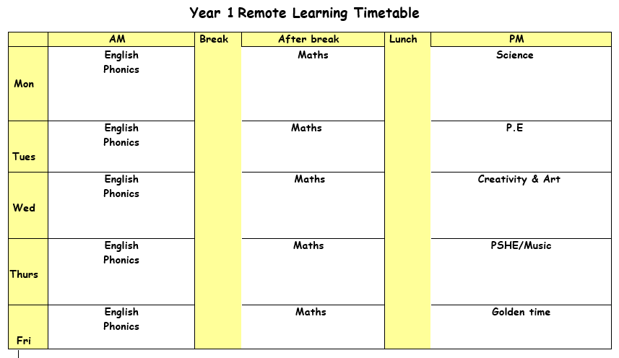

Monday 17th May 2021

ENGLISH: Reading Assessment

SPELLINGS & MENTAL MATHS
Activity 1 – Complete your spellings and mental maths test from last week (time).
Activity 2 – Next week’s Mental Maths is about money number sentences. Green group will be looking at number sentences to 20p, blue group are looking at number sentences to 30p, and red group are looking at number sentences to 50p. Practise spellings using the different ear, ere and eer sounds.
PHONICS: Use the PowerPoint on the school website for the phonics lesson today on the ‘ture’ sound. Remember to write down all of your learning in your remote learning books and send a picture to your class teacher on J2E.
BREAK
MATHS:
LUNCH
READING: Find the reading racetrack on J2E or in your packs. Remember, when you read for 15 minutes or more to get one of your racetracks signed. Let’s see which class is going to be the winning class! You need to send a picture of your completed racetrack back to your teacher!
Read one of your bug club books for this week. Write a summary of your book to sum up the main events.
SCIENCE: Last week we were learning about wild flowers and went for a walk. We are going to do the same this week but we are identifying trees from their leaves. Be careful when touching some leaves as they may be sharp/pointy.

Activity one – Go through the powerpoint and use the worksheet to identify the different types of trees.

Challenge – Can you think of a way to group the plants? E.g by colour, size.

Tuesday 18th May 2021

ENGLISH: SPAG assessment. Read my brothers teddy and write sentences in their English books to describe the teddy. Share ideas with the class.

Challenges:

PHONICS: Use the PowerPoint on the school website for the phonics lesson today on the ‘tch’ sound. Remember to write down all of your learning in your remote learning books and send a picture to your class teacher on J2E.
BREAK
MATHS:
LUNCH
READING: Pick a book that you enjoy reading. Think of a question you would write to the author of the book.
PE: PE with Joe Wicks. Just dance or cosmic kids yoga on YouTube. Follow the link to the Oak Academy PE lesson, you will be learning about how to improve your stability when moving. https://classroom.thenational.academy/lessons/how-do-i-improve-my-stability-when-moving-68v36t

Wednesday 19th May 2021

ENGLISH: Writing Assessment.
PHONICS: Use the PowerPoint on the school website for the phonics lesson today on the ‘dge', sound. Remember to write down all of your learning in your remote learning books and send a picture to your class teacher on J2E.
HANDWRITING PRACTICE: Practise writing the next letter in your new handwriting booklet. Try and think of words with these letter in and then write a list of words in cursive handwriting into your remote learning books.
BREAK
MATHS:
LUNCH
READING – Pick a story book to read. Draw a picture of your favourite part of the book. Write what is happening in the picture and say why you chose this bit of the book.

CREATIVITY: Today we are going to make our Andy Goldsworthy art work. Recap the PowerPoint from last week’s lesson all about Andy Goldsworthy. Follow the instructions on the ‘Andy Goldsworthy art activity’ sheet. Create your own piece of natural art! You can add extra outdoor materials if you want too.
Challenge: Complete as many of the ‘land art challenge cards’ as you can.

Thursday 20th May 2021
ENGLISH: Shared Read poem -
PHONICS: Use the PowerPoint on the school website for the phonics lesson today on the ‘mb' sound. Remember to write down all of your learning in your remote learning books and send a picture to your class teacher on J2E.
BREAK
MATHS:
LUNCH
READING: Log onto bug club and read one of your bug club books. Write down three questions you would ask someone to check they have read the book carefully.
PSHE: Today you are going to be thinking about people you strangers and people you can trust. Find the PowerPoint ‘strangers and safe strangers’ work through the PowerPoint and think about how each person is different.
Green group you are going to be working on the ‘who are safer strangers’ worksheet.
Blue and red group you are working on the ‘what is a safer stranger’ worksheet.

Friday 21st May 2021
ENGLISH: Complete reading comprehension
PHONICS: Use the PowerPoint on the school website for the phonics lesson today on the ‘se' sound. Remember to write down all of your learning in your remote learning books and send a picture to your class teacher on J2E.

BREAK
MATHS:
LUNCH
Golden time

