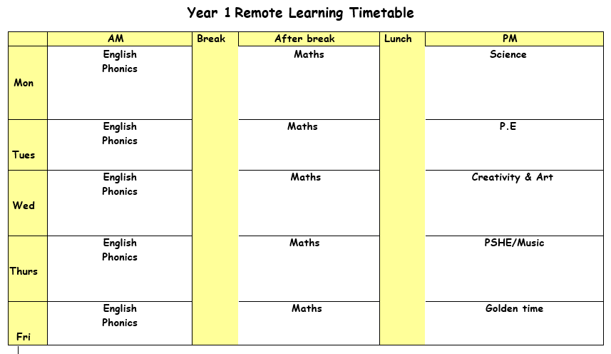

Monday 24th May 2021

ENGLISH: This week we will be looking at traditional poems. Read the Here’s the Lady’s Knives and Forks poem and use the actions suggested.
Ask children to split into groups and perform the 4 poems on page 2. Use the suggested actions while reading the poem. As a challenge can you think of your own actions?
SPELLINGS & MENTAL MATHS
Activity 1 – Complete your spellings and mental maths test from last week (adding and subtracting money).
Activity 2 – Next week there will be no mental maths test as we have set half term homework instead. You have two tasks to complete over the half term holiday. First you need to take a walk or research your local area and make a poster or booklet on what you have found. Secondly you have the next 15 Year 1 common exception words that you will be tested on, when you come back to school on Monday 7th June. You need to be able to read the words confidently and use them in saying and writing a sentence.
PHONICS: Use the PowerPoint on the school website for the phonics lesson today on the ‘wr’, sound. Remember to write down all of your learning in your remote learning books and send a picture to your class teacher on J2E.
BREAK
MATHS: Today we are going to be looking at ¼ turns. Look at the powerpoint ‘Monday maths powerpoint. Go through the powerpoint and describe the turns on the worksheet.
Activity: Describe the turns using the vocabulary, ¼ turns, half turns, clockwise and anti clockwise.
LUNCH
READING: Find the reading racetrack on J2E or in your packs. Remember, when you read for 15 minutes or more to get one of your racetracks signed. Let’s see which class is going to be the winning class! You need to send a picture of your completed racetrack back to your teacher!
Read one of your bug club books for this week. Write a summary of your book to sum up the main events.
SCIENCE: Our topic has been plants this half term. Do you think you can remember the different parts of a plant?

Activity one – Use lots of different art resources to help you make a picture of a plant. You can use pipe cleaners, foil, cupcake cases, wool, card.

Challenge – Can you label all the different parts of a plant?

Tuesday 25th May 2021

ENGLISH: Go through the verbs PowerPoint and check if you can remember what a verb is. For today’s activity use the sheets ‘my hands can’ to make up sentences about what actions you can do. Try and use as many verbs as you can.

Challenges

PHONICS: Use the PowerPoint on the school website for the phonics lesson today on the ‘kn’, sound. Remember to write down all of your learning in your remote learning books and send a picture to your class teacher on J2E. BREAK
MATHS: Today we are going to be looking at using beebots to help us describe turns. Using the beebots, can you describe turns by giving directions to each part of the beebot mat.

Activity: Describe the turns using the vocabulary, ¼ turns, half turns, clockwise and anti-clockwise and take pictures of yourself giving directions. Maybe you can write your directions down.

LUNCH
READING: Pick a book that you enjoy reading. Think of a question you would write to the author of the book.
PE: PE with Joe Wicks. Just dance or cosmic kids yoga on YouTube. Follow the link to the Oak Academy PE lesson, you will be learning about what your body does when you move. https://classroom.thenational.academy/lessons/what-does-my-body-do-when-i-move-64vkgt

Wednesday 26th May 2021

ENGLISH: Use the worksheets in English resources to add the capital letters and full stops in the correct places.
PHONICS: Use the PowerPoint on the school website for the phonics lesson today on the ‘i’, sound. Remember to write down all of your learning in your remote learning books and send a picture to your class teacher on J2E.
HANDWRITING PRACTICE: Practise writing the next letter in your new handwriting booklet. Try and think of words with these letter in and then write a list of words in cursive handwriting into your remote learning books.
BREAK
MATHS: Today we are going to be looking at practising turns. Use the learning that we have done on Monday and Tuesday to help you cut and stick the animals and shapes in the correct position. Use the ¼ turn and ½ turns to help you stick the pieces down correctly.

LUNCH

READING – Pick a story book to read. Draw a picture of your favourite part of the book. Write what is happening in the picture and say why you chose this bit of the book.

CREATIVITY: Take a walk around your local area. Look at what you can see on your walk. Take some pictures or you can draw what you have seen. See if you can notice any plants or trees that we have learnt about in science.

Thursday 27th May 2021
ENGLISH: Read the poem Arabian Nights and talk about how the actions match to the poem. Make up your own traditional poem using actions. Green group can use the examples in the resources.
PHONICS: Use the PowerPoint on the school website for the phonics lesson today on the ‘are’, sound. Remember to write down all of your learning in your remote learning books and send a picture to your class teacher on J2E. BREAK
MATHS: Today we are going to be looking at using beebots to help us describe turns. Using the beebots, can you describe turns by giving directions to each part of the beebot mat.
LUNCH
READING: Log onto bug club and read one of your bug club books. Write down three questions you would ask someone to check they have read the book carefully.
MUSIC: Follow the link to the oak academy lesson. https://classroom.thenational.academy/lessons/disjunct-melodies-6gr3ed. You will be exploring musical movements and making your own musical story.

Friday 28th May 2021
ENGLISH: Read the traditional poem and answer the questions from the worksheet. Make sure you are speaking in full sentences.
PHONICS: Use the PowerPoint on the school website for the phonics lesson today on the ‘ere’, sound. Remember to write down all of your learning in your remote learning books and send a picture to your class teacher on J2E.
BREAK
MATHS: Today we are going to be following beebot commands to help us describe our turns and direction. Input the commands into the beebots and take pictures of this.
LUNCH
Golden time

Have a lovely half term holiday!
Miss Patel, Ms Adam & Mrs Sheikh

