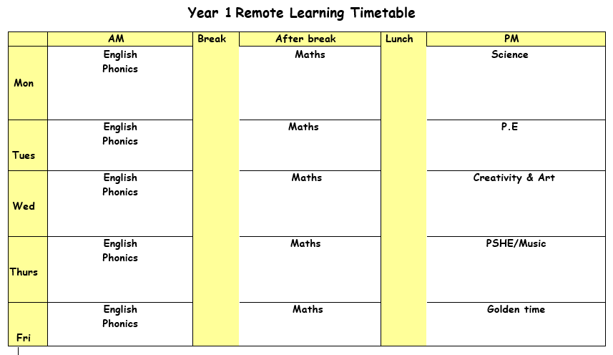

Monday 21st June 2021

ENGLISH: Imagine you are in a rocket looking out at the surface of the moon. What would you see? What does it look like?
Blue: Using ‘My trip to the Moon’ (F PCM 1.3.7), the children complete sentences about an imaginary trip to the Moon.
Green: Using ‘My trip to the Moon 2’ (F PCM 1.3.18), the children complete a sentence and draw a picture about an imaginary trip to the Moon
Red: Using ‘My trip to the Moon’ (F PCM 1.3.7), the children choose new vocabulary from the Learning Wall to complete sentences about an imaginary trip to the Moon.

SPELLINGS & MENTAL MATHS
Activity 1 – Complete your spellings and mental maths test from last week (doubling/halving/quartering).
Activity 2 – There will be no more spellings and mental maths homework. We will be sending home holiday homework and booklets in the upcoming weeks to complete over the summer break.
PHONICS: Use the PowerPoint on the school website for the phonics lesson today on the ‘wr’, sound. Remember to write down all of your learning in your remote learning books and send a picture to your class teacher on J2E.
BREAK
MATHS:
LUNCH
READING: Find the reading racetrack on J2E or in your packs. Remember, when you read for 15 minutes or more to get one of your racetracks signed. Let’s see which class is going to be the winning class! You need to send a picture of your completed racetrack back to your teacher!
Read one of your bug club books for this week. Write a summary of your book to sum up the main events.
SCIENCE: To make your own information booklet about plants.

Activity one – Use all the information about plants, trees and flowers to create an information booklet for children to read. You can include drawings with your writing.

Tuesday 22nd June 2021

ENGLISH: Today we are going to look another book called Dougal’s Deep sea diary. Introduce the book by looking at the video. Show ‘Sea life’ (F ITP 1.3.5) and discuss both sections of the video. What lives here? Why is it light/dark? What are the goggles for? Start a word bank on the Learning Wall.
Shared read to page 13.
Read Dougal’s Deep-Sea Diary to page 13.
Pages 2-3: Which person in the picture is telling the story? How is he different?
Pages 4-5: Anything unusual in this picture?
Pages 6-7: ‘I don’t usually see anything much.’ Who does that remind you of? (Bob) Explain vocabulary: ‘harbour’, ‘rickety’.
Pages 8-9: Support inference: Which dolphin is Herbert? Do the sharks really want the salad?
Pages 10-11: What was he bumping into? Explain the pun: ‘nippy’.
Pages 12-13: Was it raining?
Challenges – Use Douglas on the news to answer questions.

PHONICS: Use the PowerPoint on the school website for the phonics lesson today on the ‘kn’, sound. Remember to write down all of your learning in your remote learning books and send a picture to your class teacher on J2E. BREAK
MATHS:
LUNCH
READING: Pick a book that you enjoy reading. Think of a question you would write to the author of the book.
PE: PE with Joe Wicks. Just dance or cosmic kids yoga on YouTube. Follow the link to the Oak Academy PE lesson, you will be learning about what your body does when you move. https://classroom.thenational.academy/lessons/what-does-my-body-do-when-i-move-64vkgt

Wednesday 23rd June 2021

ENGLISH: Look through Man on the Moon and ask the children to tell you their favourite parts. Do the same with Dougal’s Deep-Sea Diary. Remind the children of the details shared and enjoyed so far.
How are these two stories similar? (E.g. same author, similar style of pictures, similar characters, similar story of not noticing things; diary / ‘day in the life of …’ format.)
How are they different? (E.g. shows a day/week; different settings; Dougal eventually notices everything; different ending.)
Which place would you rather visit – the Moon or Atlantis? Why
Green: Provide the children with three or four cut-out days and entries from ‘The mermaid’s diary’ (F PCM 1.3.8) to match up, using the pictures as a memory aid.
Red: The children complete ‘The mermaid’s diary’ (F PCM 1.3.8) by matching the entries with the correct days, using the pictures as a memory aid. Challenge them to join the simple sentences with ‘and’ to create new sentences with the sentence starter ‘This week…’ (e.g. This week I saw Dougal on TV and I swam with the sharks.).
Come back together as a class to compare answers and check them using the eBook. Reread some of Dougal’s diary entries and then the mermaid’s. Whose day sounds the most fun? Which thing would you most like to do?
PHONICS: Use the PowerPoint on the school website for the phonics lesson today on the ‘i’, sound. Remember to write down all of your learning in your remote learning books and send a picture to your class teacher on J2E.
HANDWRITING PRACTICE: Practise writing the next letter in your new handwriting booklet. Try and think of words with these letter in and then write a list of words in cursive handwriting into your remote learning books.
BREAK
MATHS:
LUNCH
READING – Pick a story book to read. Draw a picture of your favourite part of the book. Write what is happening in the picture and say why you chose this bit of the book.

CREATIVITY: Find the PowerPoint ‘seaside entertainment’. Today we are going to be looking at what seaside were like now compared to how they were in the past. Think about what you have seen or played with when you have been to the beach before. Talk about how things have changed or some similarities that there still are. You are going to be making your own Punch and Judy puppets out of paper and decorating them with different materials such as felt and fabrics.

Thursday 24th June 2021
ENGLISH: Write a diary entry for the mermaid use the worksheet from yesterday’s lesson to help you.

PHONICS: Use the PowerPoint on the school website for the phonics lesson today on the ‘are’, sound. Remember to write down all of your learning in your remote learning books and send a picture to your class teacher on J2E. BREAK
MATHS:
LUNCH
READING: Log onto bug club and read one of your bug club books. Write down three questions you would ask someone to check they have read the book carefully.
MUSIC: Follow the link to the oak academy lesson. https://classroom.thenational.academy/lessons/disjunct-melodies-6gr3ed. You will be exploring musical movements and making your own musical story.

Friday 25th June 2021
ENGLISH: Complete reading comprehension.
PHONICS: Use the PowerPoint on the school website for the phonics lesson today on the ‘ere’, sound. Remember to write down all of your learning in your remote learning books and send a picture to your class teacher on J2E.
BREAK
MATHS:
LUNCH
Golden time

