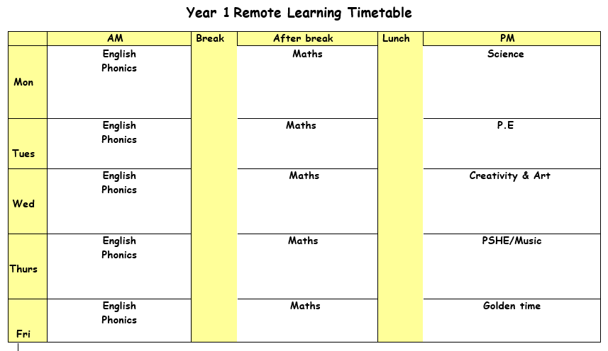

Monday 5th July 2021

ENGLISH: Work on the next 2 pages of your English summer booklet. If you do not have a copy of your booklet, you can find it on J2E. You do not need to print out the booklet, you can write down your answers in full sentences on a piece of paper.
PHONICS: Work on the next 2 pages of your phonics booklet. If you have done this, make a list of as many words as you can with the split diagraph sounds (a_e, e_e, i_e, o_e, u_e).
BREAK
MATHS: Work on the next 2 pages of your maths summer booklet. If you do not have a copy of your booklet, you can find it on J2E. You do not need to print out the booklet, you can write down your answers in full on a piece of paper.
LUNCH
READING: Find the reading racetrack on J2E or in your packs. Remember, when you read for 15 minutes or more to get one of your racetracks signed. Let’s see which class is going to be the winning class! You need to send a picture of your completed racetrack back to your teacher!
SPORTS DAY: Today would have been our sports day. Log onto J2E to see some sports day activities you can complete at home. You can include some just dances or you can make your own workout routine if you would like.

Tuesday 29th June 2021

ENGLISH: Work on the next 2 pages of your English summer booklet. If you do not have a copy of your booklet, you can find it on J2E. You do not need to print out the booklet, you can write down your answers in full sentences on a piece of paper.
PHONICS: Work on the next 2 pages of your phonics booklet. If you have done this, make a list of as many words as you can with the alternative ai sounds (ay, a_e, a, ai). Remember to put these words into full sentences.
BREAK
MATHS: Work on the next 2 pages of your maths summer booklet. If you do not have a copy of your booklet, you can find it on J2E. You do not need to print out the booklet, you can write down your answers in full on a piece of paper.
LUNCH
READING: Pick a book that you enjoy reading. Think of a question you would write to the author of the book.
MUSIC: Follow the link to the oak academy lesson. Reading and writing rhythms (thenational.academy). You are going to be reading and writing rhythms.

Wednesday 30th June 2021

ENGLISH: Work on the next 2 pages of your English summer booklet. If you do not have a copy of your booklet, you can find it on J2E. You do not need to print out the booklet, you can write down your answers in full sentences on a piece of paper.
PHONICS: Work on the next 2 pages of your phonics booklet. If you have done this, make a list of as many words as you can with the alternative ‘c’ sound, for example cent, cell. Put these words into a full sentence.
BREAK
MATHS: Work on the next 2 pages of your maths summer booklet. If you do not have a copy of your booklet, you can find it on J2E. You do not need to print out the booklet, you can write down your answers in full on a piece of paper.
LUNCH
READING – Pick a story book to read. Draw a picture of your favourite part of the book. Write what is happening in the picture and say why you chose this bit of the book.

CREATIVITY: Find the PowerPoint ‘seaside food’. Today we are going to be looking at what food they used to have at the seaside compared to now. Think about what you eat when you go to the seaside. Make yourself a seaside picnic or snack and send a picture to your teacher.

Thursday 1st July 2021
ENGLISH: Work on the next 2 pages of your English summer booklet. If you do not have a copy of your booklet, you can find it on J2E. You do not need to print out the booklet, you can write down your answers in full sentences on a piece of paper.
PHONICS: Work on the next 2 pages of your phonics booklet. If you have done this, make a list of as many words as you can with the alternative ‘g’ sound, for example gem, gent. Put these words into a full sentence.
BREAK
MATHS: Work on the next 2 pages of your maths summer booklet. If you do not have a copy of your booklet, you can find it on J2E. You do not need to print out the booklet, you can write down your answers in full on a piece of paper.
LUNCH
READING: Log onto bug club and read one of your bug club books. Write down three questions you would ask someone to check they have read the book carefully.
PANTOMINE: Today at school, we would have been watching a pantomime. I have found one similar for you to watch at home. Follow the link and enjoy! https://www.bbc.co.uk/iplayer/episode/b06s2h64/cbeebies-presents-stage-shows-alice-in-wonderland. There are some activities on J2E all about Alice in Wonderland for you to complete as well.

Friday 2nd July 2021
ENGLISH: Work on the next 2 pages of your English summer booklet. If you do not have a copy of your booklet, you can find it on J2E. You do not need to print out the booklet, you can write down your answers in full sentences on a piece of paper.
PHONICS: Work on the next 2 pages of your phonics booklet. If you have done this, make a list of as many words as you can with the sounds ‘se’ (please), ‘or’ (caught) and ‘wr’ (wrap). Remember to put these words into full sentences.
BREAK
MATHS: Work on the next 2 pages of your maths summer booklet. If you do not have a copy of your booklet, you can find it on J2E. You do not need to print out the booklet, you can write down your answers in full on a piece of paper.
LUNCH
Golden time

